**Creating Bucket (Two different Regions)**

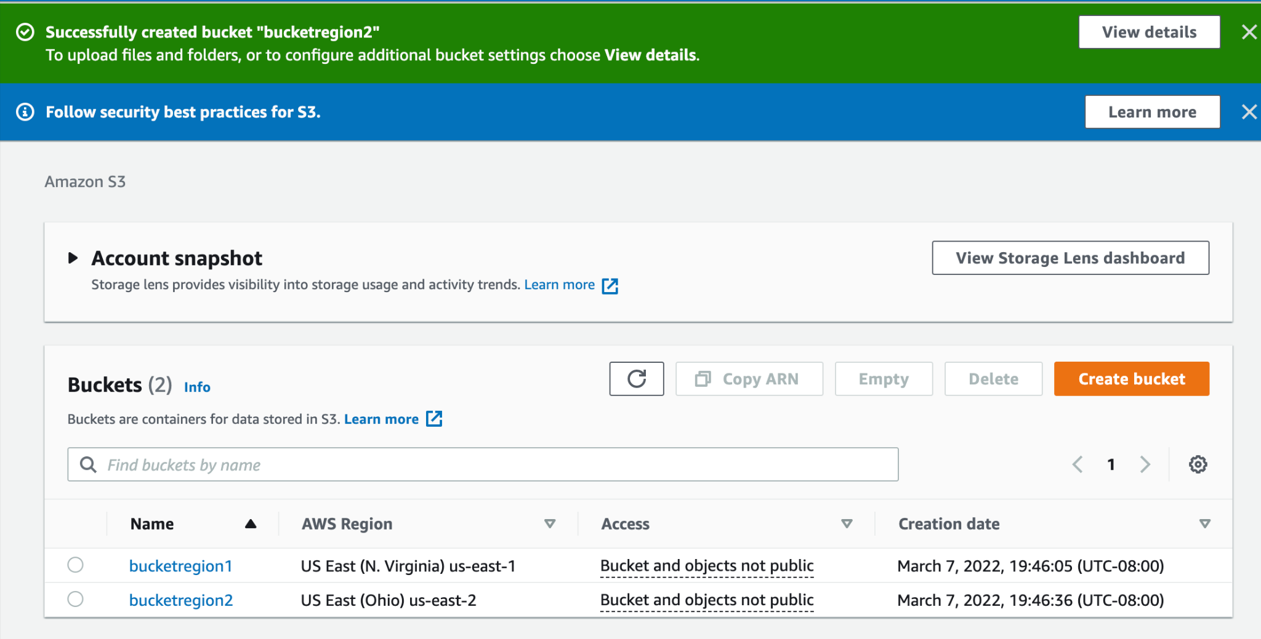

**Creating policy for Region 1 (Virginia)**

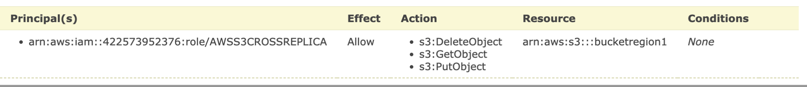

**Replication of bucketregion2 (Ohio)**

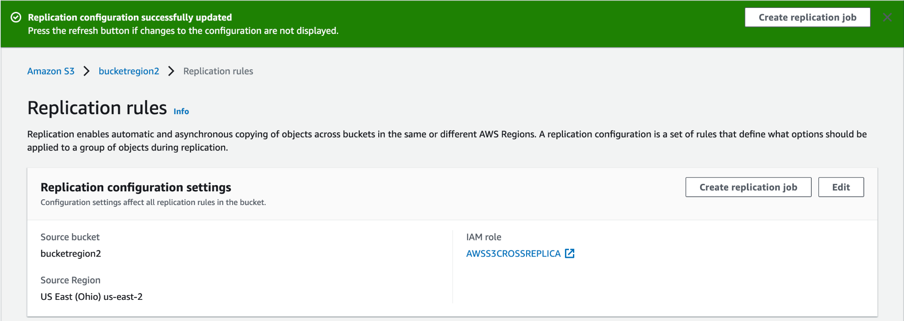

**Replication Rules**

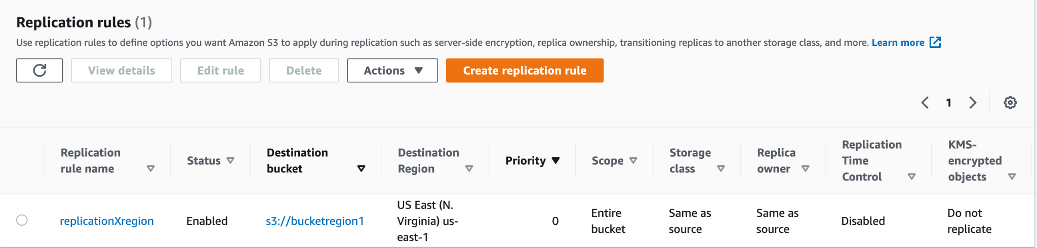

**Testing with CSV File**

**Uploading in bucketregion2**

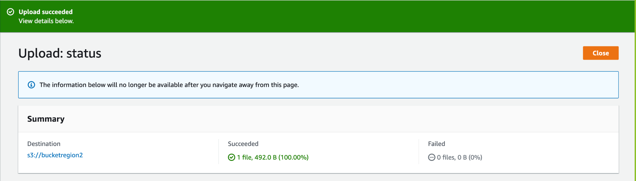

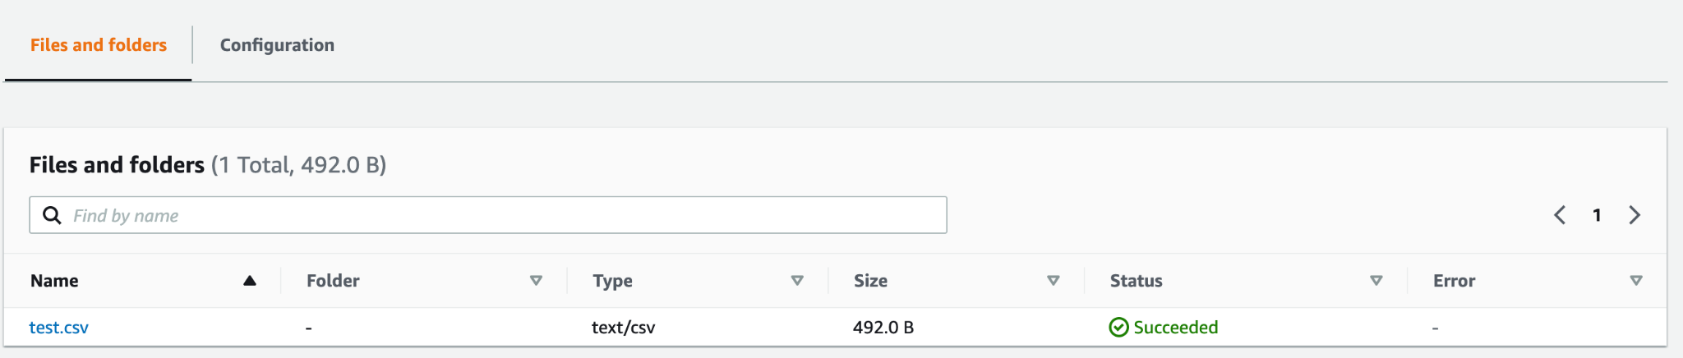

**We can see the file in Region1 as well**

